Introduction to NetBeans

The NetBeans IDE is an open-source integrated development environment written entirely in Java using the NetBeans Platform. NetBeans IDE supports development of all Java application types out of the box.

- Launch Netbeans

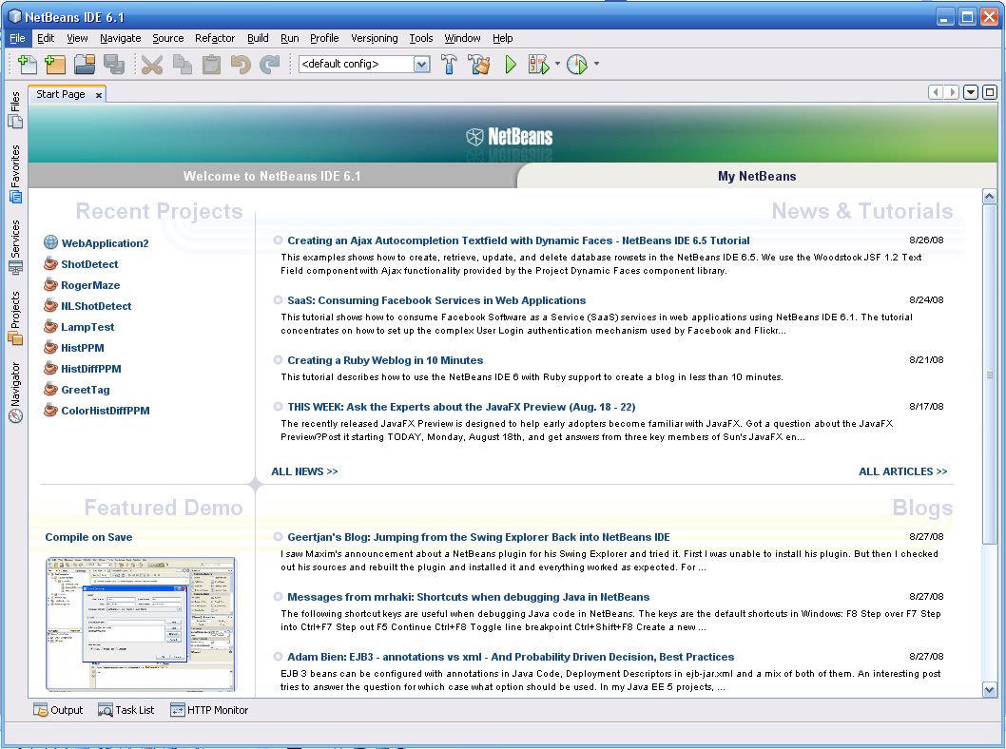

- Create a Java Project in the appropriate location.

File → New Project

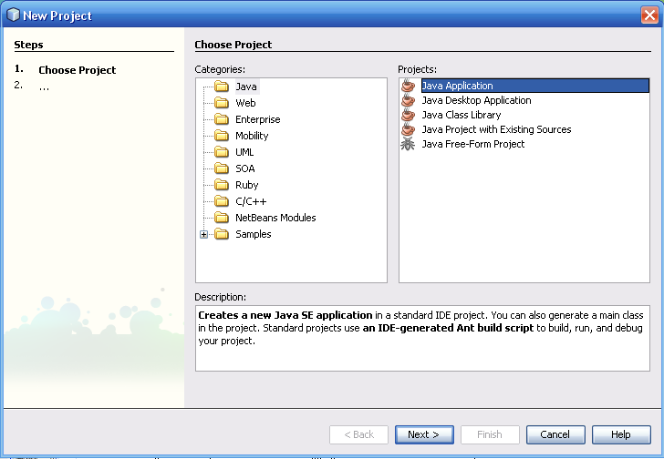

Select Java and Java Application

Click Next

- Type in the name of the Project

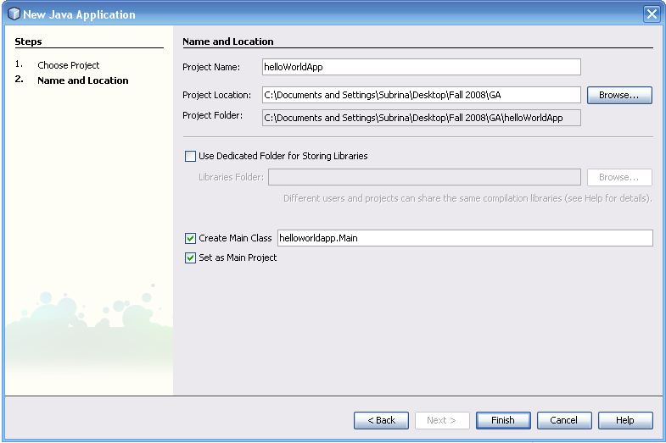

Click Finish

Your screen should look similar to the one below.

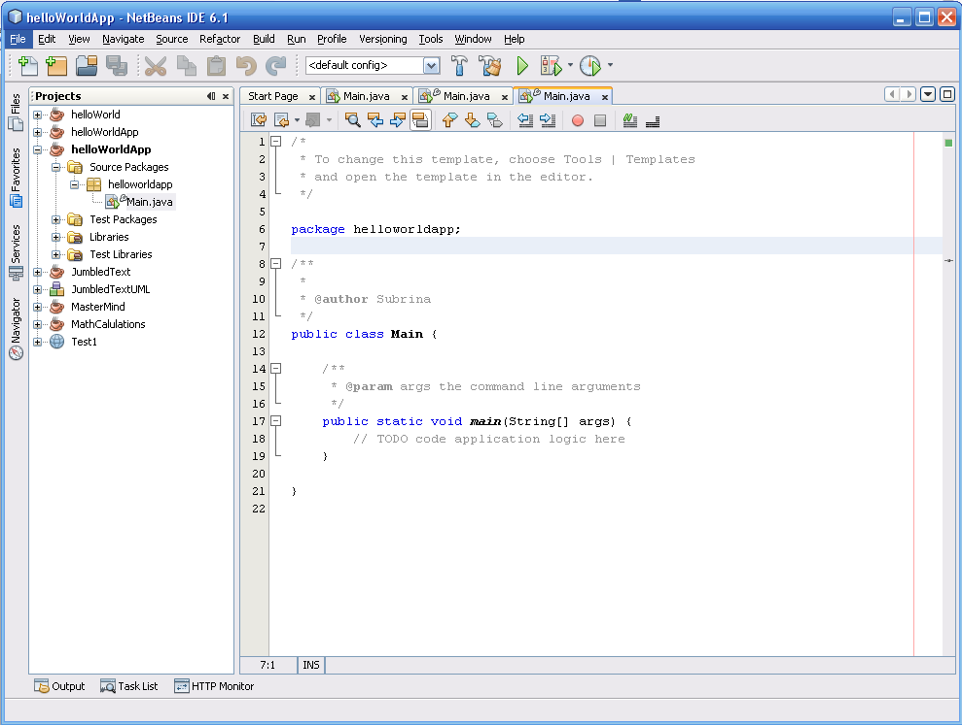

Add the following lines to the “// TODO code application logic here” section.

// Create and set up the window
JFrame frame = new JFrame("Hello World Application"); frame.setDefaultCloseOperation(JFrame.EXIT_ON_CLOSE);
frame.setSize(200, 200);

// Create Label
JLabel label = new JLabel("Hello World from Java!");

frame.getContentPane().add(label);

// Display the window
frame.pack();
frame.setVisible(true);

Import the following package:
package helloworldapp;
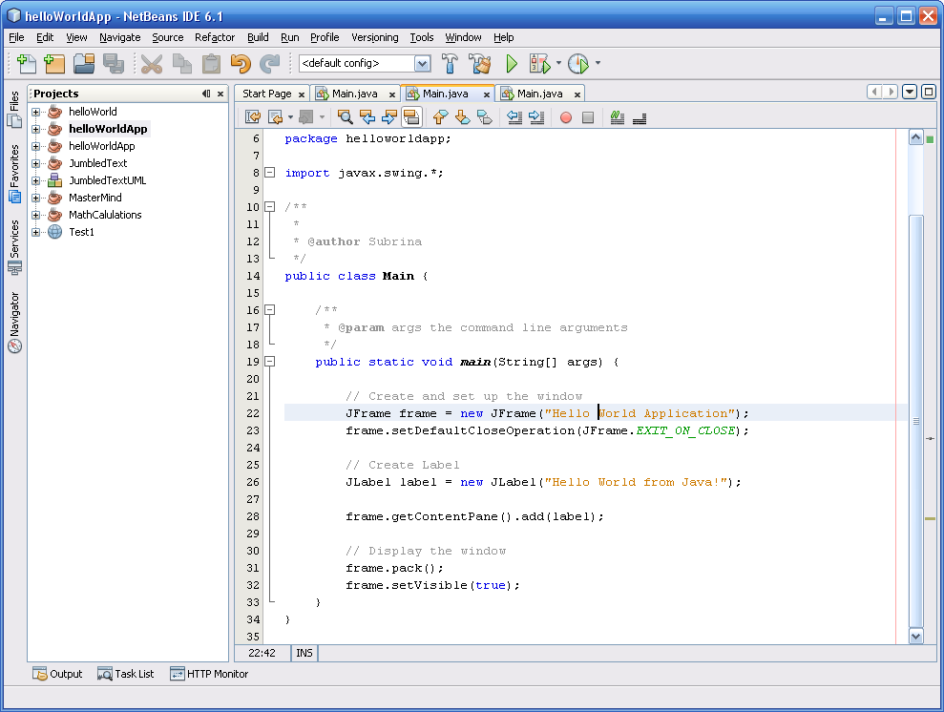

Select Build → Build Main Project

- Now Execute the Project



